**PHASE-4 THIRD PROJECT**

**OUTPUT SCREENSHOTS**

When you click **Home** button, the output will be

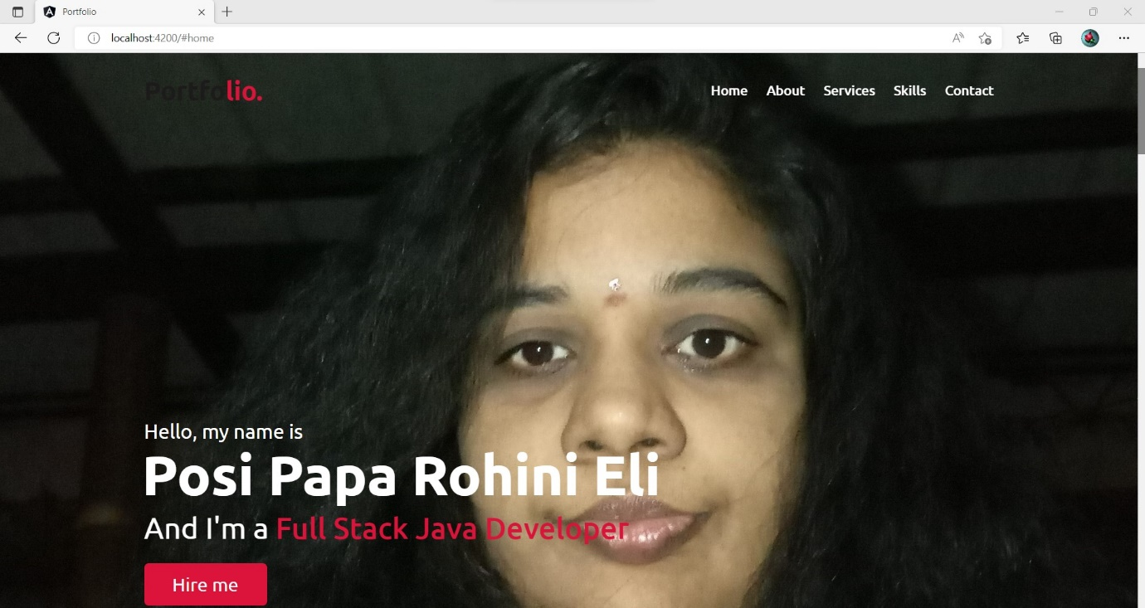

When you click **About** button, the output will be

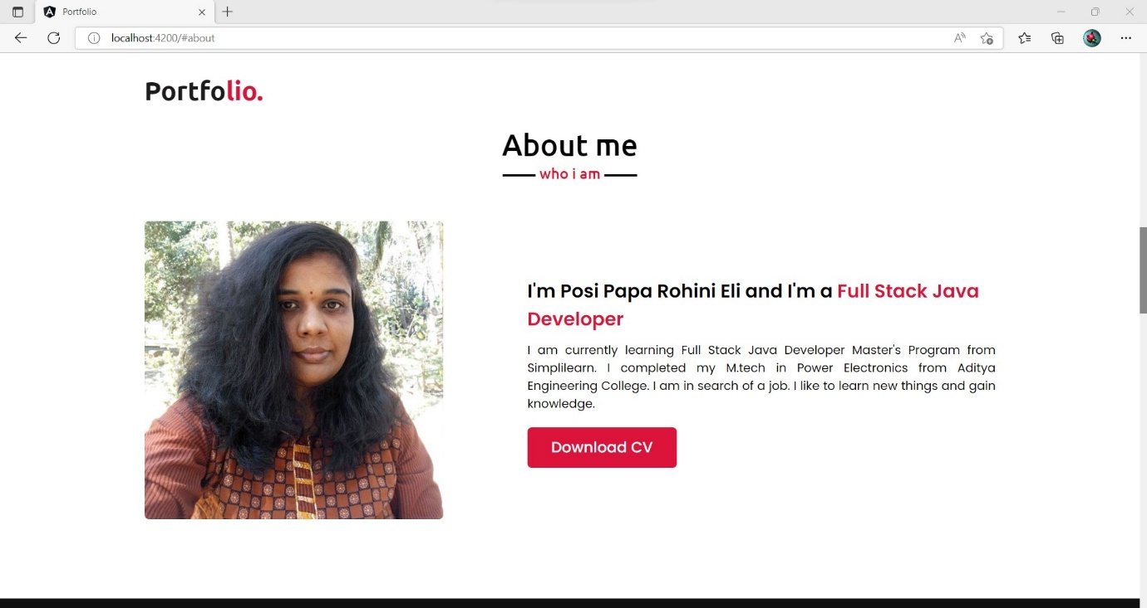

When you click **Services** button, the output will be

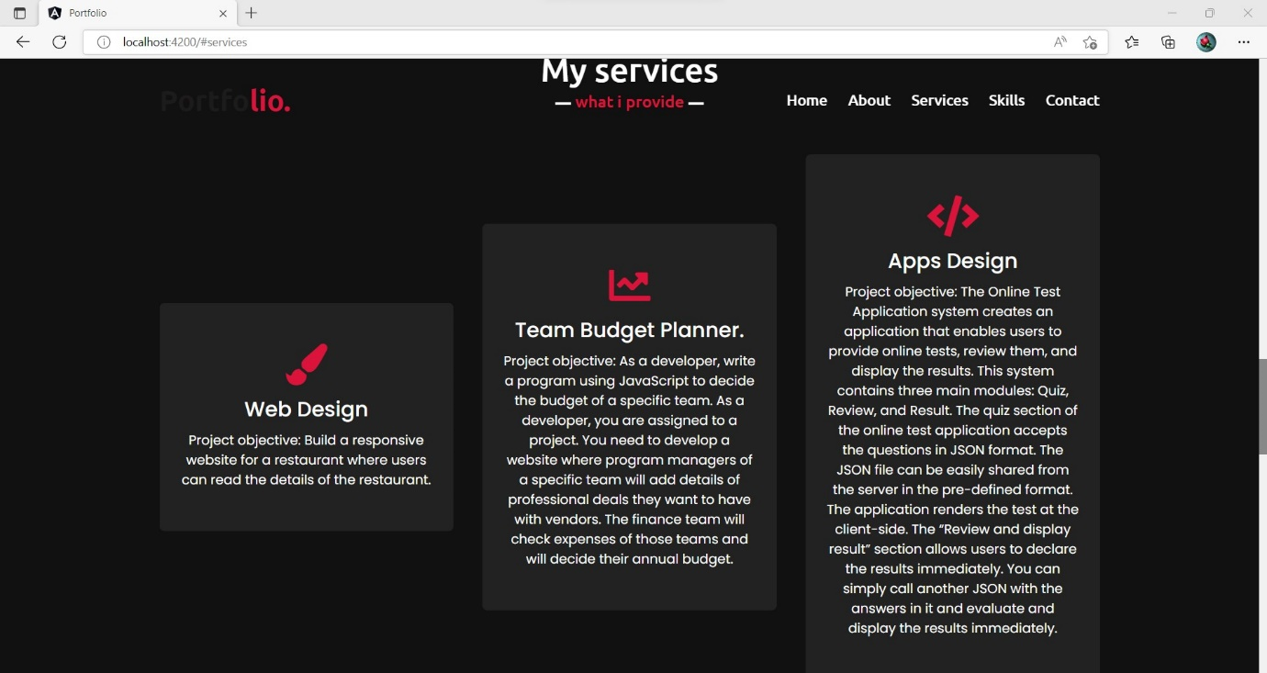

When you click **Skills** button, the output will be

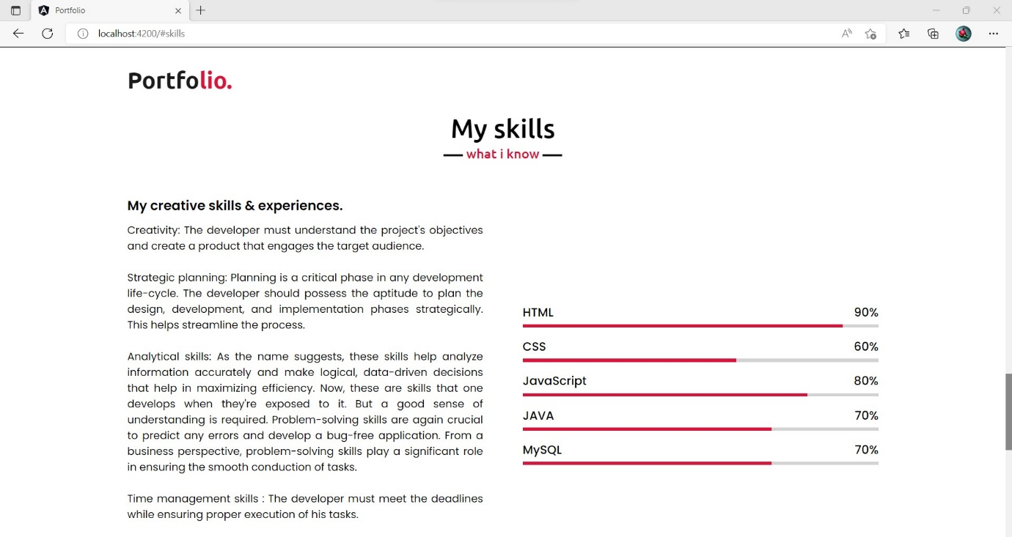

When you click **Contact** button, the output will be

